People with problems

I have always wondered if all problems are big enough. A lot of times, when I was howling over some triviality, I would ask my friend in between if it is a big enough problem. Am I being stupid and ungrateful. I think I was just being a serial howler back then. The thing is, uncomfortably so, I have realised that there are big and small problems. While playing football, one got one toenail uprooted and the other got 3 toenails uprooted. There are two problems and clearly one is bigger than the other. You are lonely and there are people who aren’t getting placed. I don’t like my job and my mother couldn’t get a job. The classification of these problems lies in your hand though, and you shouldn’t let any random person tell you the magnitude of mess you are in. A good exercise for the labelling could be imagining a switch of problems. Would you rather this problem or that problem — the problem you would choose will be the smaller problem, always, even if you are a sadist ass.

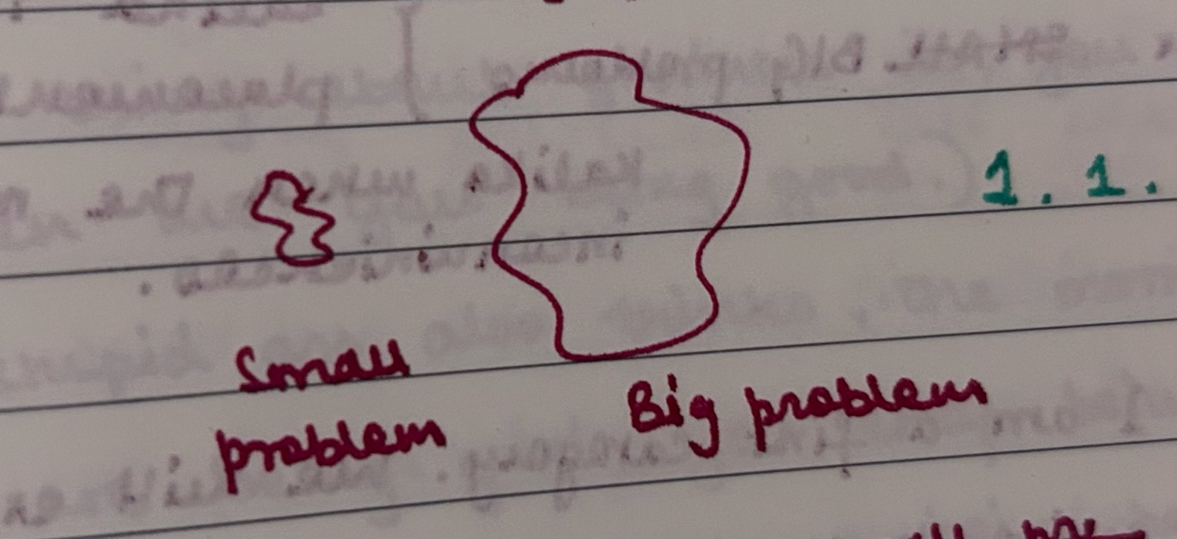

Our complex world has complex people with complex problems. And just as with problems, there are also small/big people.
A small (petty) person is someone who mostly views their problems as big problems.
A big person is someone who mostly views their problems as small problems.
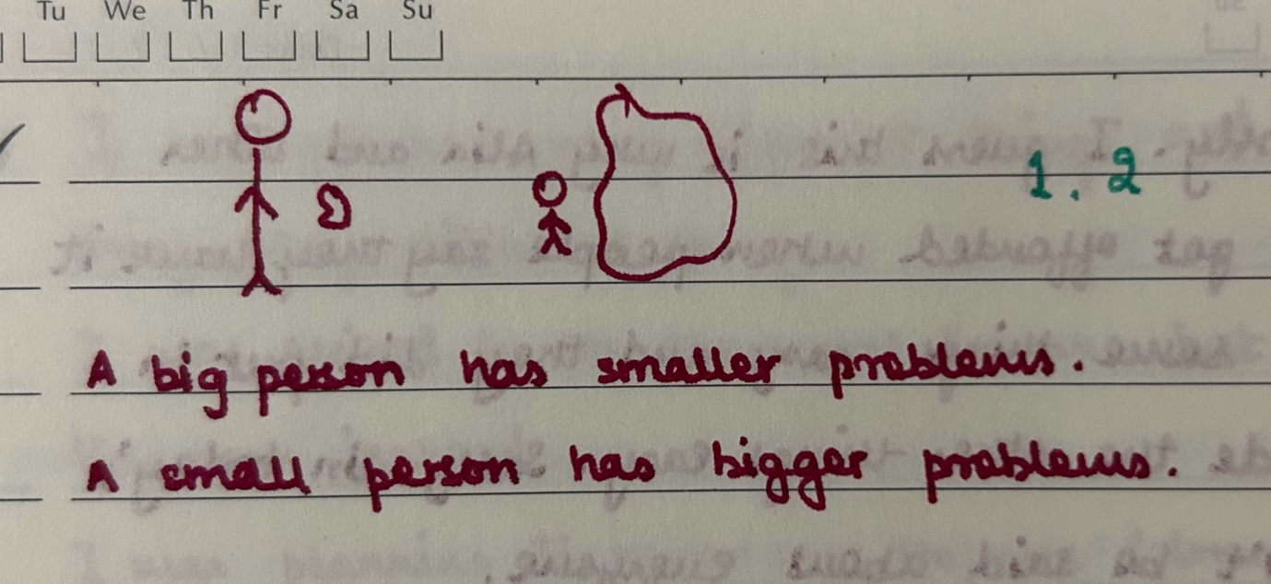

For easier identification, we can also talk about characteristic traits of the two. Small people are always whining and never find time to find out what might be up in the other person’s life because it must be some triviality. Big people care to find about lives other than their own and push everyone up because they are themselves enduring a lot of pain and hence, are quick empathisers.
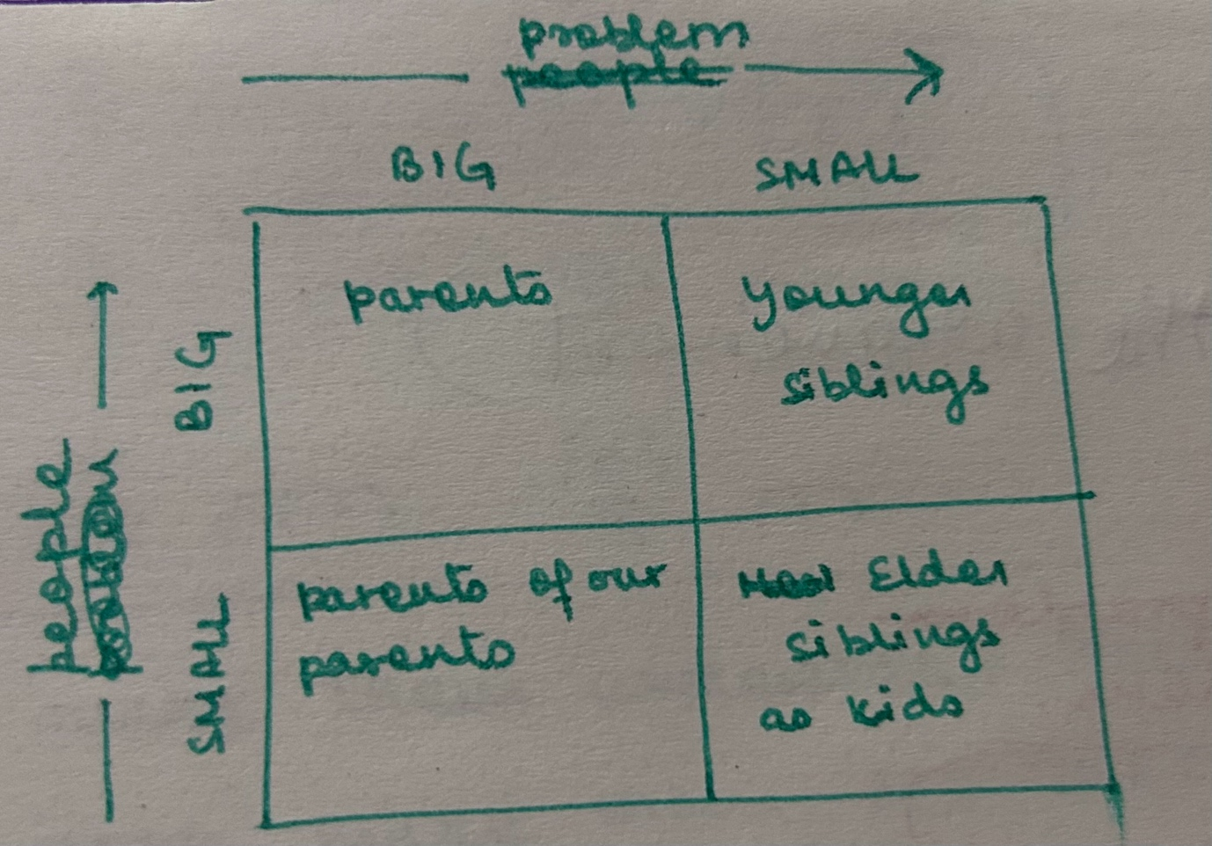

Let’s talk about big people with small problems because they aren’t talked about enough. Why ? Out of self awareness, consideration for others, smartness, big people with small problems don’t talk about their problems. That is why they are big people. Big people think that talking about their problems is rude and selfish. So, they adjust and accommodate endlessly, until they become big people with big problems. For example : You have a PPO and you live in a hell hole. You have a high paying job and higher expectations so you get high everyday. Other serious examples might include, housewives and the great respect they have in the society — remember Amu getting slapped in the film Thappad. What big people do not realise is, just as they try to maximise their bigness, the others, who lack self awareness and consideration for others, maximise their smallness. They do this subconsciously, as they themselves recall when in later moments of regret. “Do hell with you, you unaware smug petty piece of shit“ — is what I would say to them but big people forgive them.

Who am I, though? I identify as not-big people living at the mercy of big people trying to make a case for big people so that people other than me cannot exploit them.
Who are you, though? I wouldn’t know that, but an insight I have is — if you are reading this, you will only ever face small problems. I remember I just said that you should not let any random person ever tell you the size of your problems, and especially never me. But recall the problem labelling rule, there are so many problems you don’t have and imagining having them makes you want to die — so you really have small problems.
Statistically, most of our lives are about small problems. Small people should realise this. And then we can all be big people with small problems. And when someone with a big problem, actually comes up, we should all try together to make that problem small. The onus of inclusion lies in the hands of the included, remember. Destroy smallness of people and bigness of problems — to do that though, we will need more not-big, helpful, kind, most amazing people like me.

Let’s illustrate this with a good example of supernumerary seats/reservations in IITs, something I have always discussed emotionally, never sensitively and sensibly enough.
GEM[General engineering males] have problems. Girls and non-general fellows also have problems. In the past, they have had unequal amount of problems. Let’s imagine problems as the number of jumps required to be successful. Then, as shown in the diagram men used to required fewer jumps and women used to require more jumps, in the past. The current aim is to equalise the number of jumps for everyone.
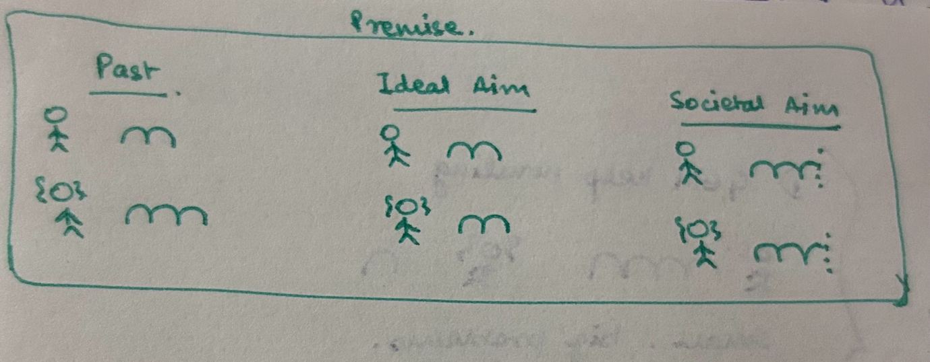
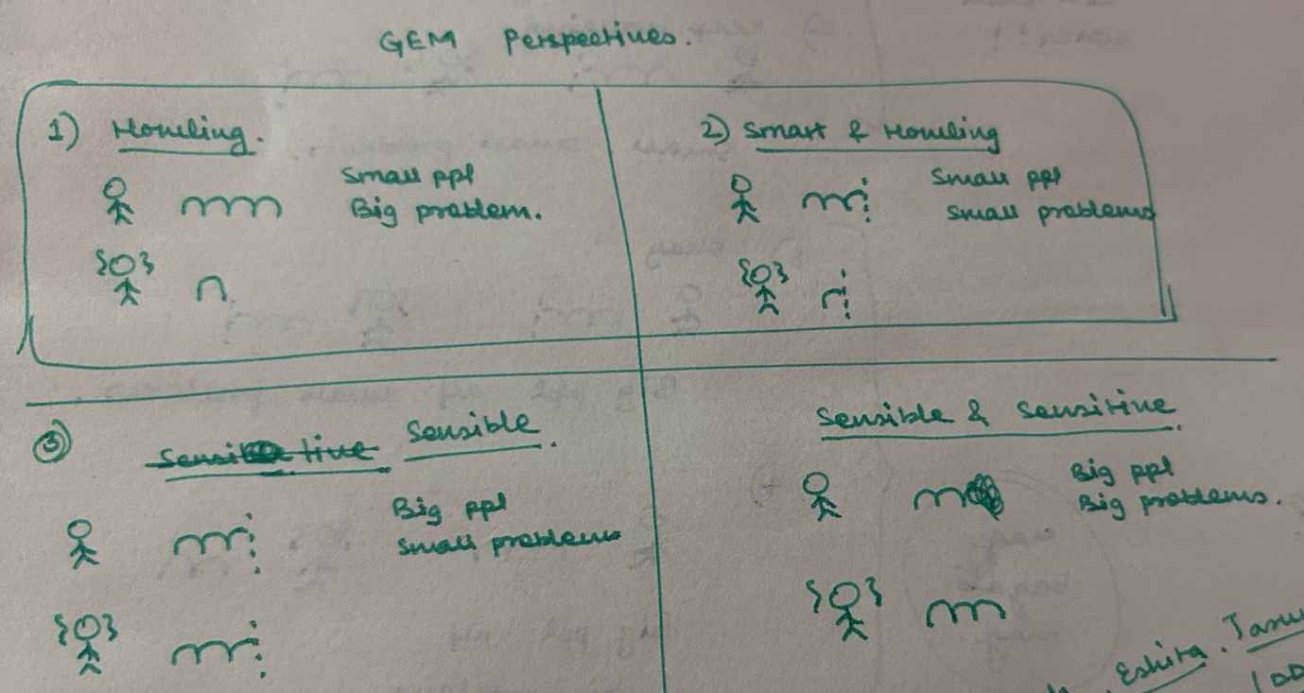

Howlers and smart howlers are both equally inconsiderate to others. Just that the latter is more self aware and they won’t make a mountain out of a molehill.
Sensible people are aware of both your and their problems. You should kiss one when you find them, as a reward on womenfolk’s behalf. Very funny.
Sensible and sensitive, big people with big problems, seem like too good to be true. But consider, if Kabir (Ranveer Singh) from Dil Dadhakne Do had to give a JEE exam, he would be one. Younger siblings with elder IITian sisters whose name starts with a ‘V’ also are strong contenders for this one. My brother, for example, was a good generous guy as of September’25.
Concluding the example my personal belief for this one is that :
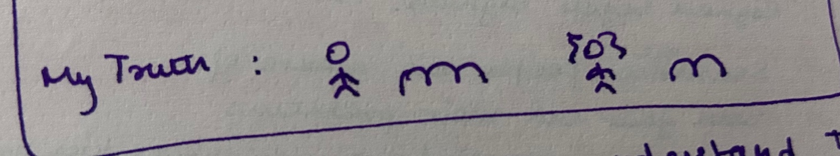The unfairness seems to have reversed a little. I don’t think, though, I would have been able to develop this view if I hadn’t discussed it with ‘big people with big problems’. Those counterintuitive motherfuckers, their bigness begets bigness.

If we think about it though, the counterintuitive bigness of people with big problems, it indeed is envy-worthy. I am such a wannabe big person with big problems — like I want my leg to break and still be unperturbed and nice and smiley. But, the inward consciousness of a man doesn’t allow him to look beyond himself in times of crisis. Some people, however, just view things differently; people who have something better than consciousness — innocence. Which allows them to practice love in a magnitude small, petty people won’t ever know and big people with small problems can only aspire for. If those are your aspirations even.

